Ohio State University

War Games AR

Design Document

Yanbo Du,
Jonathan Reed,
Zhen Tian,
Timothy Williams

Contents

1. Introduction

2. Game Mechanics & Related User Interfaces
2.1. Commander System
2.1.1. World Map Menu
2.1.2. Campaign Menu
2.1.3. Army Selection Menu
2.1.4. Upgrade Menu
2.2. Battle Settings
2.2.1. Scene Setup
2.2.2. Resource
2.2.3. Towers
2.2.4. Units
2.2.5. Spells
2.2.6. Player Unit Spawning
2.2.7. Champion System
2.2.8. Victory
3. Game Level Design
4. Miscellaneous User interfaces
4.1. Logo
4.2. Main Menu
4.3. Pause Menus
4.4. Settings Menu
5. Game State Diagram
6. Development Progress
6.1. Timebox 1 Goals
6.2. Timebox 2 Goals
6.3. Timebox 3 Goals
6.4. Timebox 4 (Base game mechanics) Goals
6.5. Timebox 5 (Advanced game mechanics) Goals
6.6. Timebox 6 Goals
6.7. Timebox 7 Goals
7. Appendix: Resources
7.1. User Interface
7.2. Models
7.3. Graphics
7.4. Particles

1. Introduction

The game wAR is a single player AR mobile tower rush game on the IOS platform. The player has the control of the battlefield and the main goal is to destroy the base of the enemy team. The player will gain gold when the team destroy towers or kill the enemy and cost gold when he/she decides to spawn new units or purchase spell. Our focus is on short games, under 5-10 minutes. Clash Royale is the main inspiration for the game.

wAR leverages the power of Unity & Apple’s ARKit 2 to bring an augmented-reality epic battle experience to iOS. At its core, wAR is a strategy game, taking inspiration from classic Warcraft III custom games, however this time, the experience is brought to your real world environment. wAR is a reverse tower defense, where the goal is to spawn in units in an effort to destroy the enemy team’s base. wAR includes multiple different unit combinations across five different levels, intertwined with a progression system and simple tech tree.

2. Game Mechanics & Related User Interfaces

2.1. Commander System
2.1.1. World Map Menu
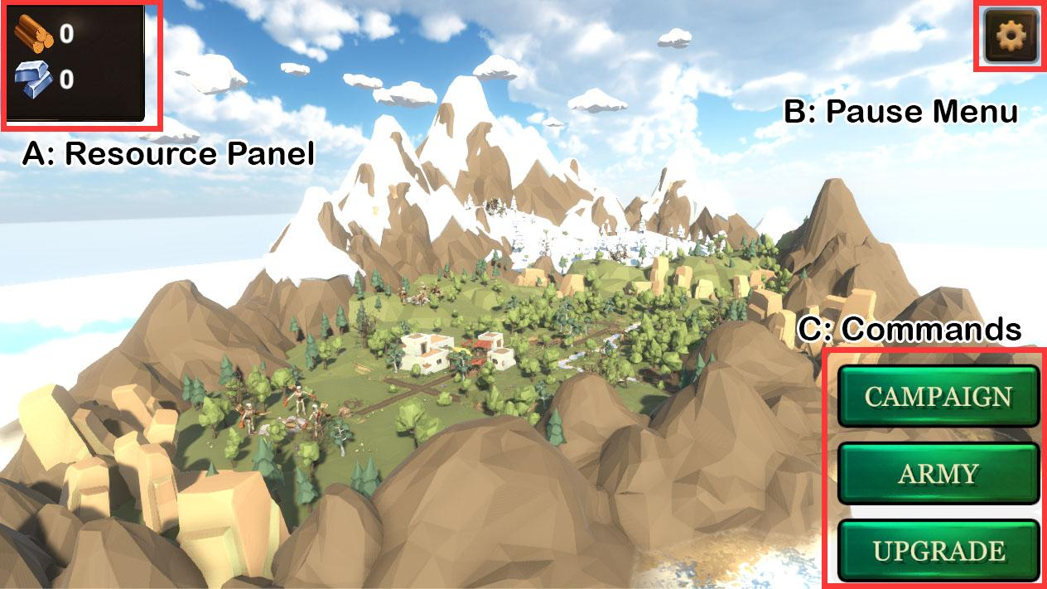
Figure 1. The World Map Menu (the Artemis Isle)

- The World Map Menu is the main command room of the Commander System.
- A is the Resource Panel:
  - There are 2 types of resources: the lumber and the iron.
    - Lumber is rich on the Artemis Isle
    - Iron is relatively scarce and hard to collect
  - Player must beat the outposts on the world map to collect resources
    - Each outpost provides different amount of resources. The amount of resource of each outpost is based on the difficulty and the geographic location.
  - Resources can be used to upgrade units.
- B is the Pause Menu. The Pause Menu allows the player to change the game settings and return to the main menu.
- C is the Commands. These are the buttons that allows player to select battles, change the composition of the army, and upgrade their units.

2.1.2. Campaign Menu
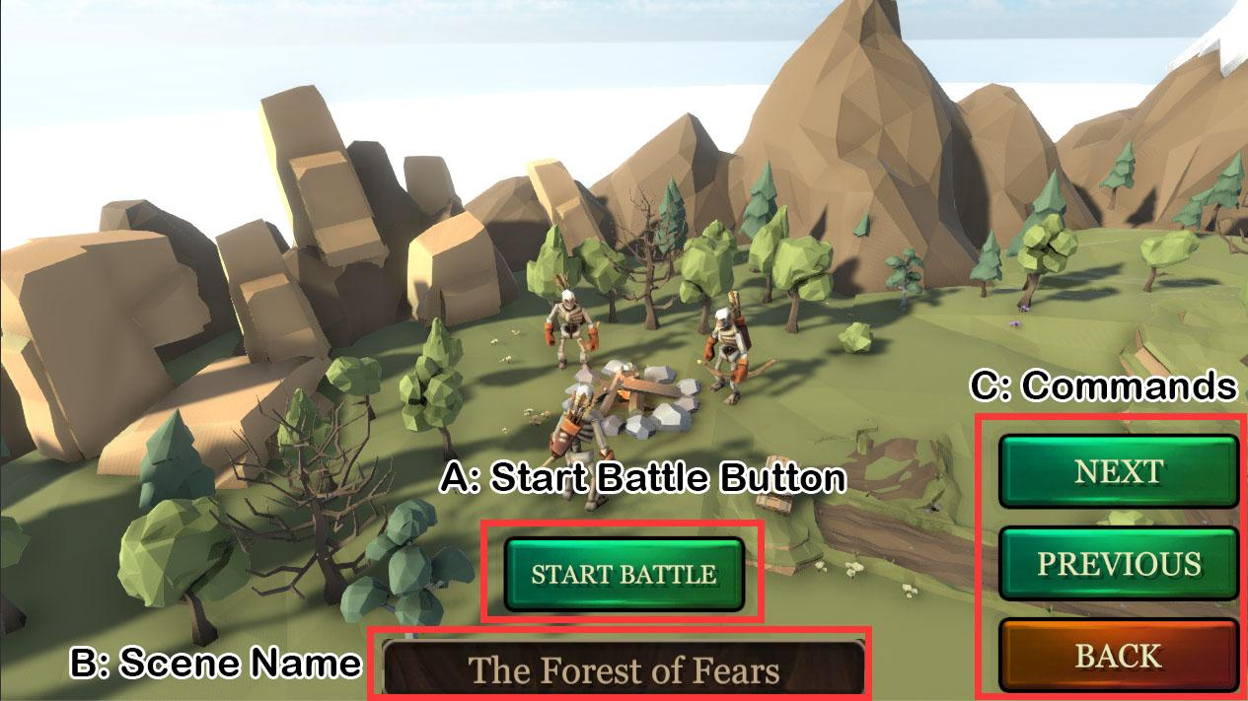
Figure 2. Campaign Menu - Unlocked Battle

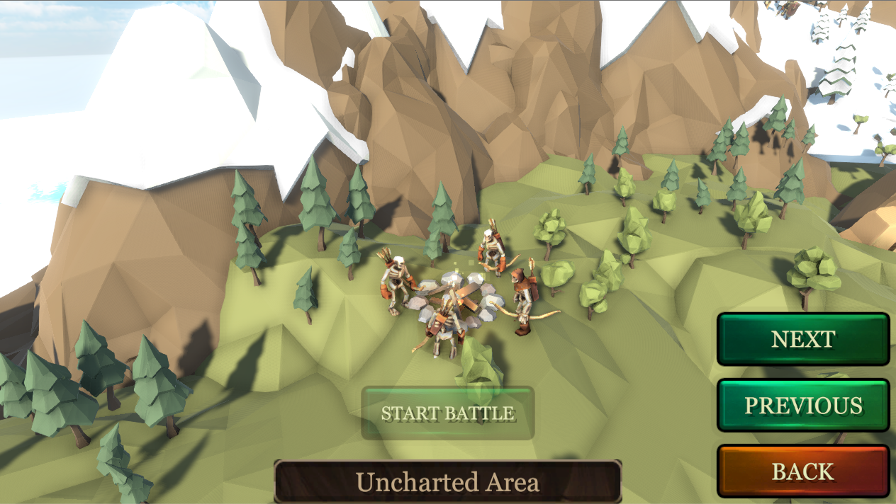
Figure 3: Campaign Menu - Uncharted Area

- The Figure 2 shows the Campaign Menu user interface. The Campaign Menu allows the players to select the battle they want to fight.
- A is the Start Battle button, and B is the Name of the Scene.
  - Figure 2: When the current battle is unlocked, then the Start Battle button is interactable, and the name tag shows the name of the current scene.
  - Figure 3: When the current battle is locked, the Start Battle button is not interactable, and the name tag shows “Uncharted Area”.
- C is the Commands.
  - Next and Previous buttons allow player to go to the next or the last battle.
  - Back button allows player to go back to the World Map Menu.

2.1.3. Army Selection Menu
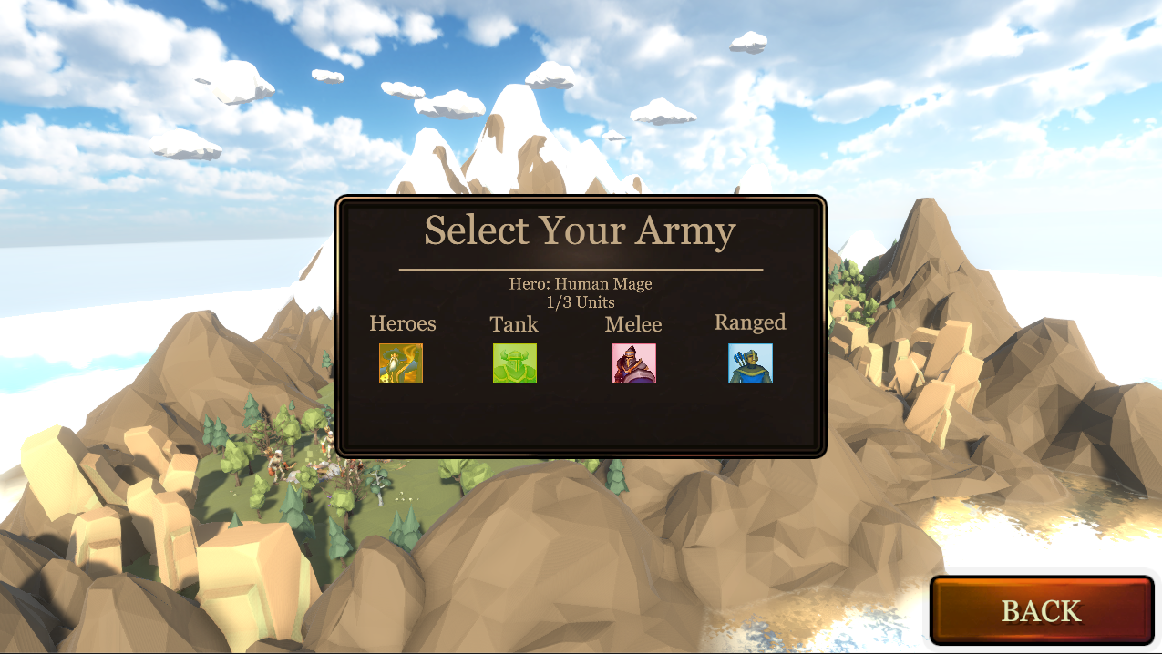
Figure 4: Army Selection Menu

- The Army Selection Menu allows players to select the Hero and regular units they want to use in battles.
- Hero unit is a very powerful unit.
  - Only one hero can be used in a battle.
  - Every hero unit has its own spell. For instance, a Human Mage can cast Fireball spell.
  - The Human Mage is the very first hero player can use in the battle. More heroes can be unlocked by beating the levels.
- Regular units:
  - Player can select at most 3 regular units in one battle.
    - Although there are 3 types of units (tanks, melee and range), players can select more than one units from the same type (For instance, a player can use both the human and undead archer in a battle).
  - As shown in the Figure 4, the portrait of the selected unit turns to green.

2.1.4. Upgrade Menu
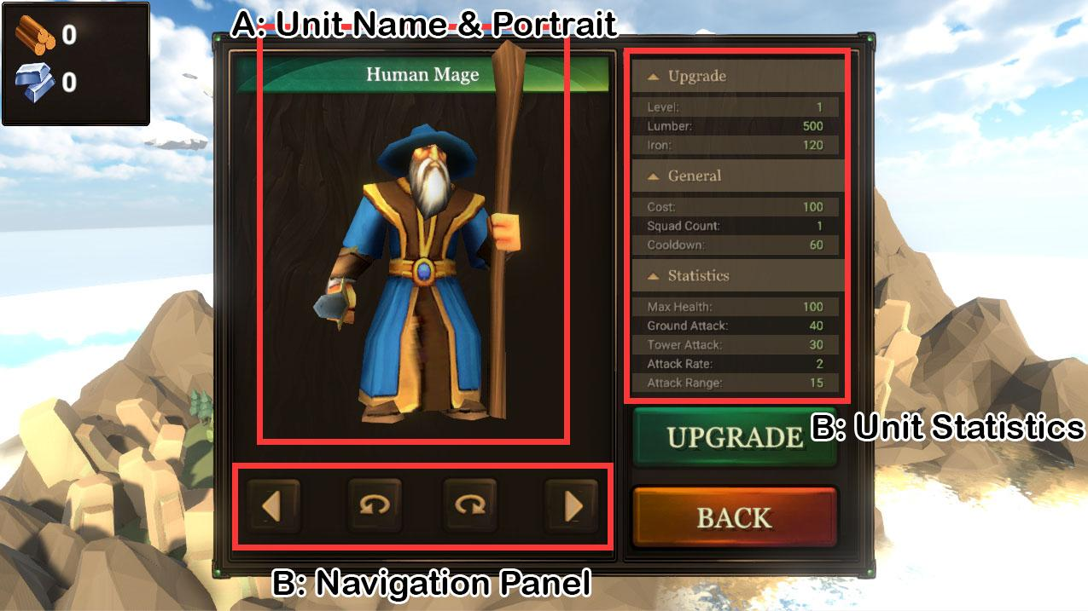
Figure 5: Upgrade Menu

- Upgrade Menu allows the players to upgrade their units.
- A shows the name and the portrait of the current unit.
- B is the Navigation Panel which allows the player to select the next/previous unit and rotate the unit model.
- C is the Unit Statistics Panel.
  - Upgrade Pane:
    - Level: current level of the selected unit. Max level is 10.
    - Lumber & Iron: the resources required to upgrade this unit.
  - General:
    - Cost: the purchase cost of the unit in a battle.
    - Squad Count: the number of units spawned
    - Cooldown: the spawn cooldown time
  - Statistics: basic statistics of the selected unit.

2.2. Battle Settings

2.2.1. Scene Setup
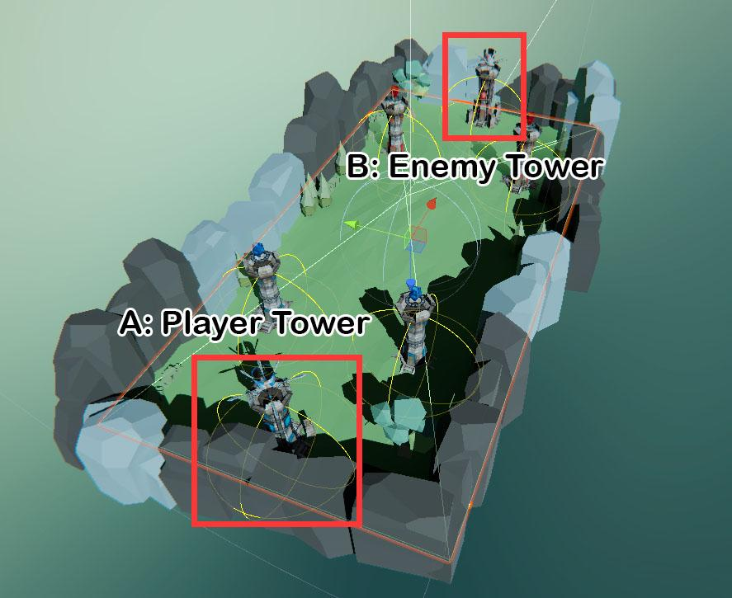
Figure 6: Scene Setup

- Levels are split up into two sides, one for the player and one for the enemy
- Level terrain is designed so that there are 3 lanes which units must walk along to reach opponent’s towers.
  - Along these lanes are the regular towers which must be destroyed to access the enemy base
- Towers:
  - Base towers for the player and enemy are always located at the end of each side of the battlefield (shown in the red squares in Figure 6).
  - Both player and the enemy have 2 regular towers.
  - Enemy towers can spawn undead units, player’s towers cannot.
- Rocks & Transparent Bounds:
  - Rocks are placed at the edge of the battlefield so the units cannot get out of the scene.
  - 6 Transparent Bound Walls cover the entire scene so that the unit will not fly out of the scene when the Bomb spell is used.
- Level asset is created for defining how much gold players start within this level and the level prefab to spawn for a level

2.2.2. Resource
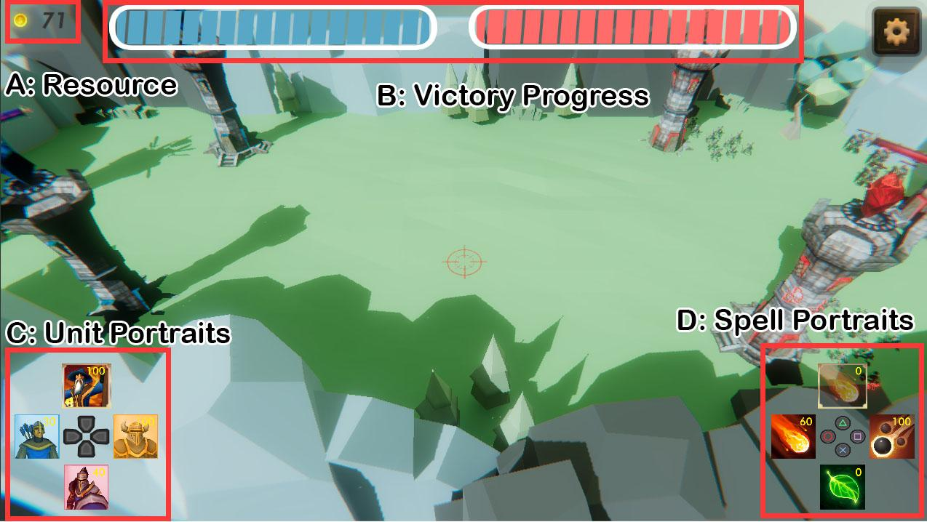
Figure 6: Battle User Interface

- Players use Gold (Figure 6: top left corner) resource to purchase either squads or player spells.
  - Gold is gained passively over time from player towers
    - Base Tower: 5 gold/s
    - Regular Tower: 3 gold/s
    - When a player tower is destroyed, it no longer provides gold to the player
  - Gold can also gain from killing enemy units or destroying enemy towers
    - Killing enemy units: reward is based on unit
      - Undead Melee death reward: 1 gold
      - Undead Tank death reward: 5 gold
    - Destroying enemy tower: 50 gold

2.2.3. Towers
- Towers are manually placed along the lanes for both player and enemy in the editor when designing the level
- Every player tower provides a certain amount of gold every second
  - This is set in the tower object editor inspector
  - When a tower is destroyed, it no longer provides that gold to the player.
- All towers can be destroyed, which allows the units to progress further along that lane
- All towers attack nearby units of the opposing team
- Enemy towers are pre-programmed to spawn squads at set time intervals
  - This programming is set up in the editor inspector of the tower
  - Editor will setup unit prefab to spawn, number of units to spawn in a squad for that prefab, and time interval to spawn units at
  - Units spawn around tower
  - Enemy towers do not gain gold for the enemy
  - As time progresses, enemy towers spawn units with higher stats
  - As time progresses, enemy towers spawn units at faster intervals
- Tower statistics settings:
  - Team: the team that this spawned tower will belong to. Team One is Player, Team Two is Enemy.
  - Tower Type: the tower type that will spawn, base/regular tower.
  - Max Health: starting health of this tower.
  - Attack Range: attacking radius of this tower in meters from the edge of the model.
  - Ground Attack Damage: damage this tower deals with each attack to other ground units.
  - Attack Rate: delay between attacks this tower can make, in seconds.
  - Gold Rate (Player Tower Only): amount of gold per second this tower gives the player.
  - Death Reward (Enemy Tower Only): amount of gold the opposing team gets when this tower is destroyed.
  - Spawn Waves (Enemy Tower Only):
    - Unit Level: level of the unit that spawns with this wave.
    - Unit Race: race of the unit that spawns with this wave.
    - Unit Type: type of the unit that spawns with this wave.
    - Squad Count: number of units to spawn each wave.
    - Spawn Start Delay: time in seconds to wait before spawning the first wave.
    - Spawn Interval: time in seconds between each wave is spawned.

2.2.4. Units

Unit statistics settings:
  - Upgrading Resources:
    - Lumber: the lumber required for upgrading the unit
    - Lumber Modifier: the growth coefficient of lumber requirement.
      - For instance, assume a unit requires 500 lumber to upgrade at level 1, if lumber modifier is 5, then it needs 2500 lumber to upgrade at level 9.
    - Iron: the iron required for upgrading the unit
    - Iron Modifier: the growth coefficient of iron requirement.
  - Purchasing:
    - Purchase Cost: cost of purchasing a squad of this unit in gold.
    - Squad Count: the number of units in a single squad of this unit.
    - Purchase Cooldown: the time in seconds player must wait after purchasing a squad of units before purchasing another.
  - Unit Stats:
    - Max Health: starting health of this unit.
    - Max Health Modifier: the growth coefficient of Max Health.
    - Ground Attack Damage: damage this unit deals with each attack to other ground units.
    - Ground Attack Damage Modifier: the growth coefficient of Ground Attack Damage.
    - Tower Attack Damage: damage this unit deals with each attack to towers and buildings.
    - Tower Attack Damage Modifier: the growth coefficient of Tower Attack Damage.
    - Attack Rate: delay between attacks this unit can make, in seconds.
    - Attack Rate Modifier: the growth coefficient of Attack Rate.
    - Attack Range: attacking radius of this tower in meters from the edge of the model.
    - Attack Range Modifier: the growth coefficient of Attack Range.
    - Death Reward: amount of gold this unit gives the opposing team when it dies.
    - Max Target Of: maximum number of enemies which can have this unit as a target at the one time.

Unit resources & purchasing statistics
Name | Race | Type | Portrait | Upgrading Resources |  |  |  | Purchasing
 |  |  |  | Lumber | Lumber  Modifier | Iron | Iron Modifier | Cost | Squad Count | Cooldown
Human Melee | Human | Melee | 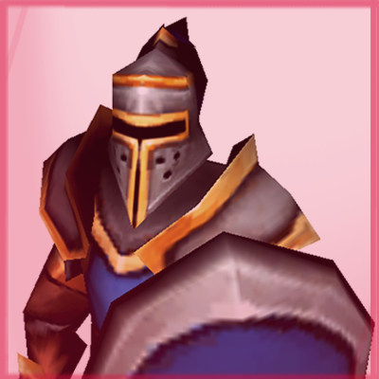 | 250 | 5 | 60 | 5 | 40 | 10 | 6
Human Tank | Human | Melee | 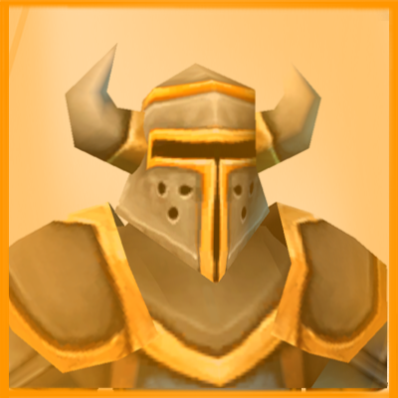 | 450 | 5 | 110 | 2 | 100 | 4 | 20
Human Archer | Human | Range | 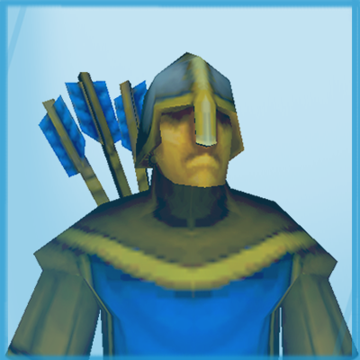 | 250 | 5 | 60 | 3 | 30 | 6 | 6
Mage | Human | Hero | 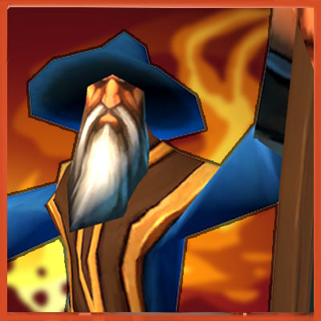 | 500 | 5 | 120 | 5 | 100 | 1 | 60
Undead Melee | Undead | Melee | 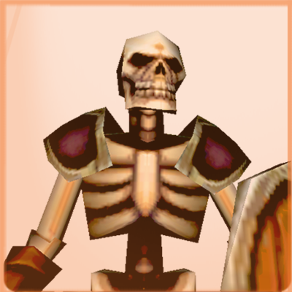 | 250 | 5 | 60 | 5 | 40 | 10 | 6
Undead Tank | Undead | Tank | 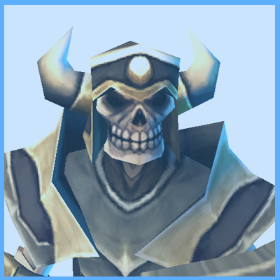 | 450 | 5 | 110 | 5 | 100 | 4 | 20
Undead Archer | Undead | Range | 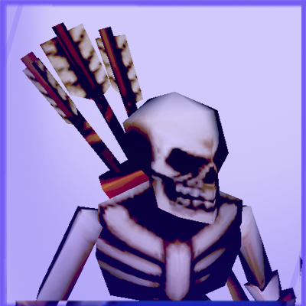 | 250 | 5 | 60 | 5 | 30 | 6 | 6

Unit general statistics
Name | Portrait | Statistics
 |  | Max Health | Health  Modifier | Ground Attack | Ground Attack Modifier | Tower Attack | Tower Attack Modifier | Attack Rate | Attack Rate Modifier | Attack Range | Attack Range Modifier | Death Reward | Max Target of
Human Melee |  | 40 | 50 | 14 | 50 | 10 | 50 | 3 | 1 | 5 | 1 | 1 | 2
Human Tank |  | 100 | 50 | 30 | 50 | 43 | 50 | 3 | 1 | 5 | 1 | 5 | 10
Human Archer |  | 20 | 50 | 20 | 50 | 15 | 50 | 3 | 1 | 15 | 1 | 1 | 2
Mage |  | 100 | 50 | 40 | 50 | 30 | 50 | 2 | 1 | 15 | 1 | 50 | 10
Undead Melee |  | 40 | 50 | 10 | 50 | 20 | 50 | 2 | 1 | 5 | 1 | 1 | 2
Undead Tank |  | 100 | 50 | 20 | 50 | 30 | 50 | 2 | 1 | 5 | 1 | 5 | 10
Undead Archer |  | 20 | 50 | 15 | 50 | 20 | 50 | 2 | 1 | 15 | 1 | 1 | 2

Heroes:
  - Potential “Super” unit you can purchase
  - Hero costs a lot
  - Hero has special ability they can use at a regular interval

2.2.5. Spells
- Tapping a player spell icon on the UI (Figure 6, D: Spell Portraits) spends gold to spawn the spell at the current reticle location
- Spell statistics settings:
  - Spell Purchasing:
    - Purchase Cost: cost of purchasing this spell in gold.
    - Purchase Cooldown: the time in seconds player must wait after purchasing this spell before purchasing another.
  - Spel Statistics:
    - Spell Radius: radius this spell effects in meters
    - Max Duration: time in seconds spell is removed. 0 means spell will be removed immediately after casting.
    - Effect All Teams: should this spell effect both teams?
    - Spell Damage: total damage the spell does over its entire duration.
    - Explosion Force (Bomb Spell): force explosion applies to units in radius.
    - Upwards Explosion Modifier (Bomb Spell): modifier to explosion force to make it seem to lift object more.

Name | Icon | Purchasing |  | Statistics
 |  | Cost | Cooldown | Radius | Max Duration | Effect All Teams | Spell Damage | Explosion Force | Upwards Explosion Modifier
Bomb | 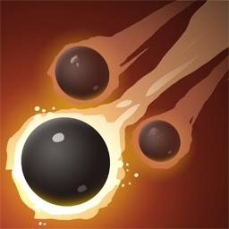 | 100 | 3 | 10 | 0 | No | 100 | 40 | 2
Firestorm | 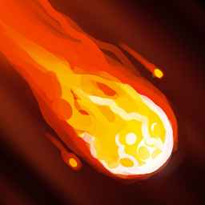 | 60 | 3 | 10 | 5 | No | 100 | N/A | N/A
Heal | 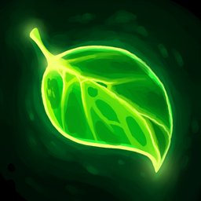 | 80 | 3 | 10 | 5 | No | -200 | N/A | N/A

2.2.6. Player Unit Spawning
- Tapping a unit portrait on the UI spends gold to spawn a squad of those units at the current reticle location
  - If the player does not have enough gold, or the unit type is on cooldown, the portrait is gray
  - Every time the player spawns a unit, that portrait goes on “Cooldown”
- When units are spawned, they choose the “Lane” closest to them and then target the enemy or tower which is furthest (towards players side) along the lane
- As units kill enemies in the lane, they move further down the lane to the next closest enemy or tower

2.2.7. Champion System
- If a unit kills a certain amount of enemy units, it will be promoted and become more powerful
- All modifiers are applied to the base stat, so level 3 saying 50% means that the base value of that stat is multiplied by 1.5
- Gives incentive for players to heal units and keep them alive over the course of the game
- MAX unit level is 3

Level |  | # Enemy Kills | Stat Scaling
 |  |  | Model Scale | Hit Point | All Attack |  | Attack Speed | Speed(meter/s)
1 |  | 5 | +20% | +10% | +20% |  | / | /
2 |  | 15 | +30% | +20% | +40% |  | +10% | +10%
3 |  | 25 | +50% | +50% | +100% |  | +50% | +20%

2.2.8. Victory
- As shown in the Figure 6, B is the Victory Progress.
  - Blue is player, Red is enemy.
  - Victory progress is calculated based on the current health of all three towers.
    - More specifically, it is based on the overall health percentage (OHP) and the base tower health percentage (BHP).
    - If OHP > BHP, then victory progress = OHP
    - If BHP > OHP, then victory progress = BHP
- The player has a Base Tower which they must defend
  - Base towers are placed at the left and right ends on the battlefield
  - The goal of the game is to destroy the base tower on the enemy team
  - If the player’s base tower health reaches 0 the player loses
  - If the enemy’s base tower health reached 0 the player wins

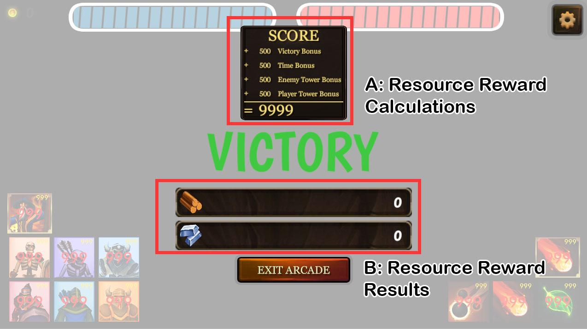
Figure 7: Resource Rewards

- Players can gain resource rewards (Lumber and Iron) when they win the battle.
  - The reward calculation is based on:
    - Base Victory Reward: the basic reward player can obtain from winning a battle.
    - Tower Health Reward: the reward that calculated based on the tower progress player’s team.
      - Tower Health Reward = Player Tower Progress * Tower Reward Modifier
      - Tower Reward Modifier is set by developer.

3. Game Level Design
- There are 5 levels in the Beta version:
  - 1 - The Forest of Fears
  - 2 - Highland
  - 3 - Dark Wood
  - 4 - Frozen Village
  - 5 - Ice Hills
- Each level has different tower settings as well as enemy spawning waves.
- Tower settings:
Level | Tower Type | Statistics
 |  | Max Health | Attack Range | Ground Attack Damage | Gold Rate (Player Only) | Death Reward (Enemy Only)
1 - The Forest of Fears | Base | 500 | 20 | 21 | 5 | 50
 | Regular | 400 | 20 | 21 | 5 | 50
2 - Highland | Base | 5944 | 20 | 250 | 5 | 50
 | Regular | 4756 | 20 | 250 | 5 | 50
3 - Dark Wood | Base | 14111 | 20 | 593 | 5 | 50
 | Regular | 11289 | 20 | 593 | 5 | 50
4 - Frozen Village | Base | 19556 | 20 | 821 | 5 | 50
 | Regular | 15644 | 20 | 821 | 5 | 50
5 - Ice Hills | Base | 25000 | 20 | 1050 | 5 | 50
 | Regular | 20000 | 20 | 1050 | 5 | 50

- Spawn Waves:
Level | Tower | Wave Details
 |  | Unit Level | Unit Name | Unit Race | Unit Type | Squad Count | Spawn Start Delay | Spawn Interval
1 - The Forest of Fears | Base | 1 | Undead Tank | Undead | Tank | 4 | 0 | 15
 | Regular 1 | 1 | Undead Archer | Undead | Range | 10 | 10 | 20
 | Regular 1 | 1 | Undead Melee | Undead | Melee | 10 | 0 | 20
 | Regular 2 | 1 | Undead Melee | Undead | Melee | 10 | 10 | 20
 | Regular 2 | 1 | Undead Archer | Undead | Range | 10 | 0 | 20
2 - Highland | Base | 3 | Undead Tank | Undead | Tank | 4 | 0 | 15
 | Regular 1 | 3 | Undead Archer | Undead | Range | 10 | 10 | 20
 | Regular 1 | 3 | Undead Melee | Undead | Melee | 10 | 0 | 20
 | Regular 2 | 3 | Undead Melee | Undead | Melee | 10 | 10 | 20
 | Regular 2 | 3 | Undead Archer | Undead | Range | 10 | 0 | 20
3 - Dark Wood | Base | 6 | Undead Tank | Undead | Tank | 4 | 0 | 15
 | Regular 1 | 6 | Undead Archer | Undead | Range | 10 | 10 | 20
 | Regular 1 | 6 | Undead Melee | Undead | Melee | 10 | 0 | 20
 | Regular 2 | 6 | Undead Melee | Undead | Melee | 10 | 10 | 20
 | Regular 2 | 6 | Undead Archer | Undead | Range | 10 | 0 | 20
4 - Frozen Village | Base | 8 | Undead Tank | Undead | Tank | 4 | 0 | 15
 | Regular 1 | 8 | Undead Archer | Undead | Range | 10 | 10 | 20
 | Regular 1 | 8 | Undead Melee | Undead | Melee | 10 | 0 | 20
 | Regular 2 | 8 | Undead Melee | Undead | Melee | 10 | 10 | 20
 | Regular 2 | 8 | Undead Archer | Undead | Range | 10 | 0 | 20
5 - Ice Hills | Base | 10 | Undead Tank | Undead | Tank | 4 | 0 | 15
 | Regular 1 | 10 | Undead Archer | Undead | Range | 10 | 10 | 20
 | Regular 1 | 10 | Undead Melee | Undead | Melee | 10 | 0 | 20
 | Regular 2 | 10 | Undead Melee | Undead | Melee | 10 | 10 | 20
 | Regular 2 | 10 | Undead Archer | Undead | Range | 10 | 0 | 20

4. Miscellaneous User interfaces

4.1. Logo
Figure 8: Logo

- Logo Page shows the War-Game-AR game logo.
- The logo is an animation made with Adobe After Effect.

4.2. Main Menu
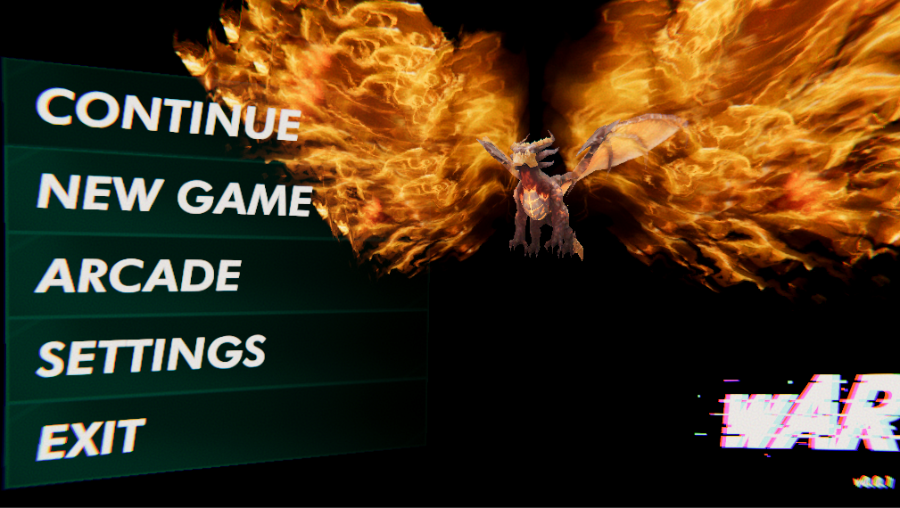
Figure 9: Main Menu

- The Main Menu allows players to continue their adventures, start a new story, go to arcade mode, change game settings, or quit the game.
- Continu:
  - All player’s progress data (such as unlocked levels, unit levels, resources) are saved automatically during the gameplay, players do not need to save their progress themselves.
  - Players can only have one saved file at the same time.
- New Game:
  - Player can start a new story here.
  - If there exists a saved file, the player must decide whether to overwrite the existing saved file.
- Arade:
  - Arcade mode is the endless mode which allows players to fight the battles until they lose the game.
  - The highest score will be recorded and will be displayed to all players.
  - The score is based on (Figure 7 - A):
    - Victory Bonus: based on the battles the player wins
    - Time Bonus: based on the time the player spent on this battle. The shorter the time is, the higher the score will be.
    - Enemy Tower Bonus: based on the enemy tower destroyed by the player.
    - Player Tower Bonus: based on the player tower remaining on the battlefield in each level.
- Settings: the player can change the audio settings here.
- Exit: player can quit the game here.

4.3. Pause Menus

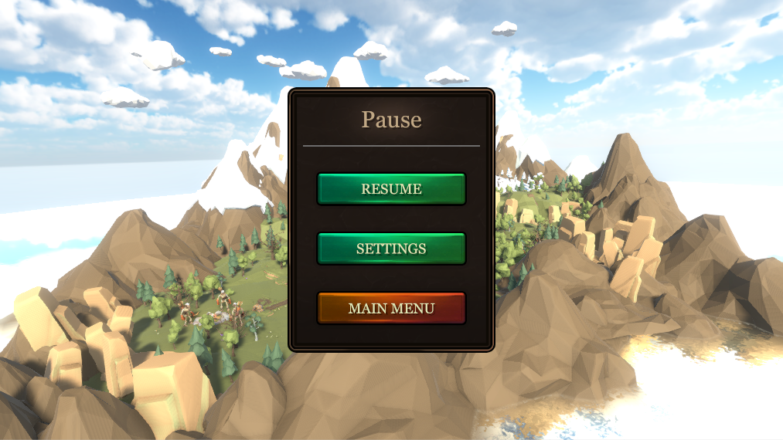
Figure 10: World Map Pause Menu

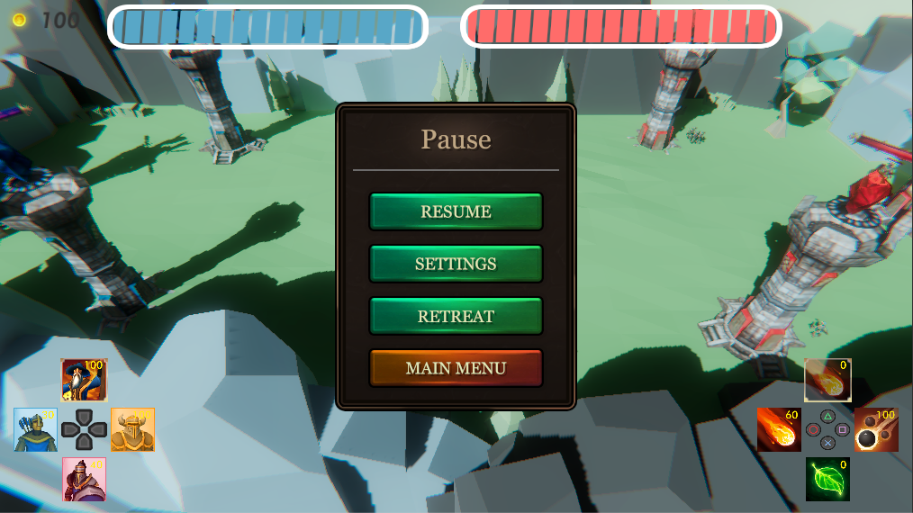
Figure 11: Battle Pause Menu

- Figure 10 shows the pause menu in the world map.
  - This pause menu allows player to change game settings, and return to the main menu
- Figure 11 shows the pause menu in the battle.
  - It is similar to the pause menu in the world map.
  - Retreat command allows player to return to the world map.

4.4. Settings Menu
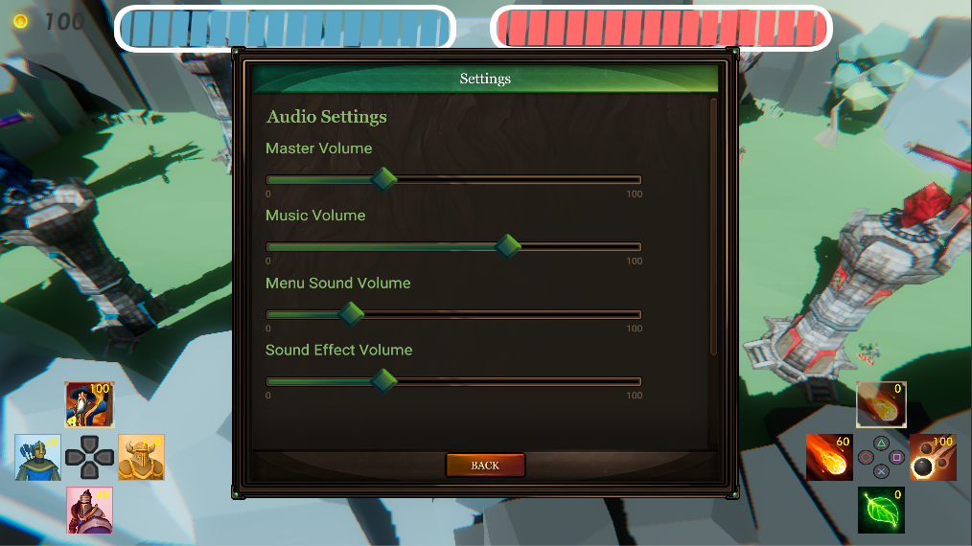
Figure 12: Settings Menu

- Player can change the Audio Settings in the settings menu:
  - Master Volume: the audio volume that applies to all sounds
  - Music Volume: the background music volume
  - Menu Sound Volume: the sound volume when interacting with menus
  - Sound Effect Volume: the volume of all sound effects in the game, for instance, the attack sounds.

5. Game State Diagram
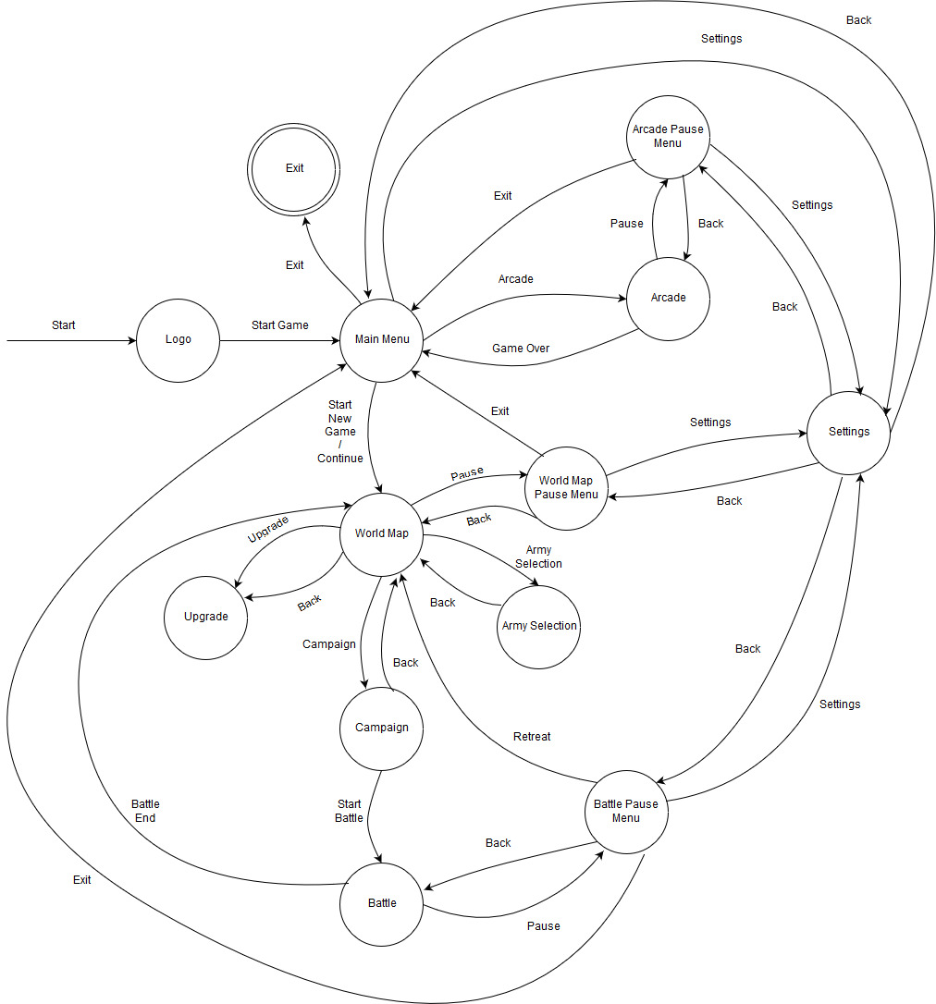

6. Development Progress
6.1. Timebox 1 Goals:
- Complete PONG game
- Do research on war simulator games
- Complete basic game design
- Complete presentation slides

6.2. Timebox 2 Goals:
JON:
- Spawning of goal circle in middle of scene
- Reticle for what phone is currently pointing at
- Scene scale manager

Chenzhang/Zhen:
- AI navigates to nearest objective when spawned
- AI attacks nearest enemy unit within attack range, no priority.
- Squads can keep track of health and die
- Damage unit type (no models or animation, no specific AI)

Yanbo/Zhen:
- UI counter at top for goal progress
- UI counter for life spirits
- Passive life spirit generation
- Ability to spend life spirits on squads
- Single squad portrait you can click to spawn squad
  - Goes gray if not enough life spirits to purchase quad
  - Tapping portrait spawns squad at current reticle location
  - Squads can be spawned anywhere, even in goal
- Basic music for game
- Basic menu music
- Updated main menu
- Network lobby menu
- Victory screen
- Write game design doc for two races, maybe some back story to help design?
- Write game design doc for the basics of all 6 unit types

TIM:
- Basic networking
  - Lobby
  - World sync
  - Squad spawning
  - Squad death
  - Goal percent updates
  - Winning/game end
- Scene loader/manager

6.3. Timebox 3 Goals:
- Resource Manager
  - Gold UI Sprite and text (Zhen)
    - Updates with current player gold count periodically (Zhen)
  - Ability to spend gold (Chenzhang)
  - Ability to gain gold over time (Chenzhang)
  - Function to gain gold (Chenzhang)
- Level prefab system
  - Spawn point class that can be placed on terrain to spawn object at that point. (Jon)
  - Spawn point editor visual (Jon)
  - Level asset which points to prefab and attributes for level
    - Starting currency (Jon)
- 1st Level
  - Create level prefab with tower spawn points, base spawn points (Jon)
  - Setup spawn intervals for each enemy tower (Jon)
  - Add terrain texture to 1st level and setup colliders for lanes (Jon)
- Towers
  - Find “Base” tower 3D model (Yanbo)
  - Find “Spawner” tower 3D model (Yanbo)
  - Find particle effect/animation for tower attacks (Yanbo)
  - Red texture for enemy towers like clash royale (Yanbo)
  - Blue texture for ally textures like clash royale (Yanbo)
  - Set up enemy “Spawner” tower prefab
    - Has 3D model (Jon)
    - Visual effect so user knows it is enemy (Jon)
    - Has enemy tower class (Jon)
  - Set up player “Spawner” tower prefab
    - Has 3D model (Jon)
    - Visual effect so user knows it is player (Jon)
    - Has player tower class (Jon)

6.4. Timebox 4 (Base game mechanics) Goals:
- Design Doc:
  - Create table of stats for towers, similar to unit table (Zhen)
  - Create table of stats for spells, similar to unit table (Zhen)
- Scripting
    - All towers:
      - Registers with object manager so it knows position along lane (Tim)
      - Attack range (Tim)
      - Attack damage (Tim)
      - Attack speed (Tim)
      - Health (Tim)
      - Dies when HP reaches 0 (Tim)
        - Tower model disappears (Tim)
        - De-registers from object manager so units know they can progress along lane (Tim)
        - Updates victory UI with progress for team (Tim)
      - Attacks units of opposing team when within range (Tim)
    - “Base” tower class
      - Sends event to victory manager when destroyed (Tim)
    - “Player” tower class
      - Provides gold every second (Tim)
    - “Enemy” tower class (without time scaling)
      - Can specify prefabs to spawn, number of units that spawn for each prefab, and time interval squads are spawned at for each prefab (Tim)
      - When destroyed gives boost of gold (Tim)
- Victory Manager
  - UI for player base tower health (Yanbo)
  - UI for enemy base tower health (Yanbo)
  - Player wins when enemy base health points reach 0 (Chenzhang)
  - Enemy wins when player base health points reach 0 (Chenzhang)
  - On Game Ended:
    - Game pauses (Chenzhang)
    - Text shows who won (Chenzhang)
    - Simple button prompt user to return to menu or exit game (Chenzhang)
- Unit spawning (Without cooldown)
  - UI
    - Find 4 human portrait art assets (Yanbo)
    - Setup UI with 4 portraits (Jon)
  - Scripting
    - Turns portrait gray when player lacks gold (Jon)
    - Tapping a portrait spawns unit squad in the scene for gold (Jon)
- Unit AI:
  - Create unit type enum (Tim)
  - Add “Lane” logic (Tim)
    - When a unit is spawned, they select the lane nearest to them (Tim)
    - Units select enemy/tower furthest along lane to attack (Tim)
  - Units can attack towers (Tim)
  - When enemy unit dies, gives gold to player (Tim)
- Object manager:
  - Can be used to locate tower/unit furthest along lane for either team (Tim)
- Unit Prefabs
  - Find human melee unit 3D model with animations (Zhen)
  - Find human ranged unit 3D model with animations (Zhen)
  - Find skeleton melee unit 3D model with animations (Zhen)
  - Find skeleton ranged unit 3D model with animations (Zhen)
  - Set up prefab for each unit type:
    - Hook in animations (Jon)
    - Set stats on agent class according to design doc (Jon)
- Spawner Reticle
  - Restrict area to player half of game surface (Tim)
  - Reticle changes color when in an area you cannot spawn at (Tim)

6.5. Timebox 5 (Advanced game mechanics) Goals:
- Level Manager
  - Ability to select level prefab in main menu, then have it spawned in by the level manager on load (Jon)
  - Handles spawning all elements of the level prefab correctly (Jon)
  - Starting currency set to whatever value is in the loaded level prefab (Jon)
- Post Processing
  - Research what post processing effects have minimal impact on mobile (Jon)
  - Experiment with different post processing effects that have good enough performance on mobile (Jon)
- Visual Effects
  - Add tower attack projectile, potentially with particles (Jon)
    - Find particle/object for projectile (Jon)
    - Use object pooling so it doesn’t kill performance (Jon)
    - Triggered on attack (Jon)
    - Instantly moves to target unit (Jon)
  - Ranged unit attack projectile, potentially with particles (Jon)
    - Find particle/object for projectile (Jon)
    - Triggered on attack (Jon)
    - Instantly moves to target unit (Jon)
- Playtesting
  - Adjust Human unit stats based on testing to what seems fair (Yanbo & Zhen)
    - Update design doc with decided values (Yanbo & Zhen)
  - Adjust Undead unit stats based on testing to what seems fair (Yanbo & Zhen)
    - Update design doc with decided values (Yanbo & Zhen)
  - Adjust tower stats based on testing to what seems fair (Yanbo & Zhen)
    - Update design doc with decided values (Yanbo & Zhen)
  - Adjust enemy tower spawn waves to be more interesting and still fair. (Yanbo & Zhen)
- Additional Levels
  - Setup two additional levels which have different terrains and unit spawn waves from enemy towers (Yanbo & Zhen)
- Destroyed tower model
  - When destroyed, tower switches to this model (Jon)
  - Should still have the same collider bounds as the tower (Jon)
  - Particle effect for during destruction (Jon)
  - Smoke/fire after destruction (Jon)
- Unit AI
  - Fix bugs with unit and tower AI (Tim)
  - Improve local avoidance of units so they stop getting stuck on eachother (Tim)
  - Unit Death animation
    - Death animation begins playing when they switch to dead state (Tim)
    - After death animation finishes, cleanup happens (Tim)
    - Hook in death animation for each unit type (Tim)
- Unit Prefab setup
  - Scale up all units (Jon)
  - Setup prefab for human tank unit using one of the found models (Tim & Jon)
    - Include animation (Tim & Jon)
    - Set stats based on design doc (Tim & Jon)
    - Add button to UI for spawning (Tim & Jon)
  - Setup prefab for undead tank unit using one of the found models (Tim & Jon)
    - Include animation (Tim & Jon)
    - Set stats based on design doc (Tim & Jon)
- Cooldowns for unit portraits
  - When pressed, portrait goes on cooldown and cannot be clicked (Chenzhang)
  - When cooldown finishes, portrait can be clicked again (Chenzhang)
- Spells
  - All
    - Portrait turns gray when player does not have enough gold (Tim)
    - Portrait turns gray when spell is on cooldown (Tim)
    - Create base code for spell functionality (Tim)
    - Tapping portrait spawns spell at current reticle location and lowers player gold (Tim)
  - Heal
    - Find UI portrait for heal spell (Yanbo)
    - Setup UI for heal spell (Jon)
    - Find particle effect for heal spell (Jon)
    - Make it so heal spell heals all units within a radius of the reticle (Tim)
  - Bomb
    - Find UI portrait for bomb spell (Yanbo)
    - Setup UI for bomb spell (Jon)
    - Find particle effect for bomb spell (Jon)
    - Make it so bomb spell damages all enemy units within a radius of the reticle (Tim)
- Lane graphics
  - Some sort of overlay texture on the terrain to make it obvious where the lanes are. (Zhen)
    - Should look natural, like Clash Royale
- Story
  - Create rough draft of script for one level for review (Zhen)
- Audio
  - Find combat sound effects (Yanbo)
    - Can just be general fighting noise loop for now. Look for war sounds from shows, games, etc.
  - Find heal spell sound effect (Yanbo)
  - Find bomb spell sound effect (Yanbo)
  - Find menu button select sound effect (Yanbo)
  - Find tower destruction sound effect (Yanbo)
  - Find victory music (Yanbo)
  - Find defeat music (Yanbo)
  - Implement audio files found by Yanbo (Jon)
- AR scene calibration ability
  - Fix AR bug where you can’t replay (Jon)

6.6. Timebox 6 Goals:
- Commander System
  - Create or complete tasks for gem system (Zhen & Yanbo)
  - Create or complete tasks for commander system (Zhen & Yanbo)
- New Levels
  - Create any levels needed for commander system (Zhen & Yanbo)
  - Think about new levels’ game mechanics and add to design doc (Chenzhang)
- New Units
  - Find models for any new units we think may be fun to add (Zhen & Yanbo)
  - Create design doc entries for units we think may be fun (Zhen & Yanbo)
  - Create UI portraits for new units added from task above (Jon)
  - Setup prefabs for new units based on models and design doc entries from above tasks (Tim)
  - Allow player to select which units they use from main menu
    - Army Menu
      - Create “Army” menu UI background (Jon)
      - Create main menu button that opens this menu (Jon)
      - Create actual buttons for selecting units in army (Tim)
      - Make it so selecting a unit for an army sets the playerpref (Tim)
    - Create code in game scene which disables portraits for units not selected by player (Tim)
  - Setup unit UI with grid layout, so we can have all units on UI canvas at once and disable ones not used (Tim)
- Audio
  - Setup spatial audio sources on towers (Jon)
  - Setup spatial audio sources on spells (Jon)
- Victory/Defeat
  - Fix bugs with victory manager (Tim)
  - Game end animation
    - When team loses, victory manager sets flag to start animation before going to end screen (Tim)
    - Base tower destruction animation plays first, and somehow sends notification to victory manager when done (Jon)
    - Once victory manager gets notification that base destruction animation is done, it displays the victory/defeat UI (Tim)
  - Update victory/defeat UI with better looking assets (Jon)
- Spells
  - Setup spell UI with grid layout, so we can have all spells on UI canvas at once and optionally disable ones not used for that level (Tim)
  - Allow spells to apply effect to units in their radius (Tim)
  - Allow explosive spells to knock back units in radius (Tim)
  - Allow spells to effect both teams (Tim)
  - Make spell effect be over duration, rather than each tick (Tim)
  - Change current “Bomb Spell” to more accurate “Fire Storm” (Tim)
  - Find explosion particle for new bomb spell which knocks back (Jon)
  - Find blizzard spell particle effect (Yanbo)
  - Find blizzard spell UI portrait (Yanbo)
  - Add blizzard spell (Tim)
- Champion Mechanic
  - Create base code for tracking unit kills and level (Tim)
  - Create static manager for tracking stat/scale modifiers for each champion level, as well as how many kills each level requires (Jon)
  - Setup static champion level manager with stat modifiers from design doc (Jon)
- Heroes
  - Find model for fire mage hero (Jon)
  - Find fireball attack projectile for fire mage hero (Jon)
  - Setup fire mage hero prefab as ranged unit who uses fire projectiles instead of arrows (Tim)
  - Setup code which allows hero to cast spells. Decide if this should be automatic, or based on a UI button press by the player. (Tim)
- Unit AI
  - Figure out why Units sometimes just stand still (Tim)
  - Make units always face target (Tim)
- Unit Death animation
  - Anyone targeting this unit selects a new target during death anim (Tim)
- Tower Destruction
  - Explosion particle effect for destruction (Jon)
  - Tower explosion deals damage and knocks back all nearby units on both teams (Tim)

6.7. Timebox 7 Goals:
- Commander System
  - Finish whatever needs done with this (Zhen)
- Design Doc
  - Remove parts of document we are no longer using (Jon)
  - Update the UI section with pictures of the current UI (Jon)
  - Update any tables with current names and stats (Units, spells, etc) (Jon)
- UI
  - Make portrait for undead tank unit (Jon)
- Game Trailer
  - Create trailer video for Crawfis by 12/5 (Yanbo & Jon)
- Presentation Poster
  - Create draft of poster and submit to Crawfis by 11/27 (Yanbo & Jon)
  - Create final poster versions and submit to Crawfis by 12/4 (Yanbo & Jon)
- Website
  - Setup website for Crawfis (Zhen)
  - Fill in any extra info needed (Yanbo & Zhen)
- Add credits page/scene to main menu
  - Button on main menu which takes you to “Credits” scene (Tim)
  - Button in “Credits” scene which returns you to main menu (Tim)
  - When credits finish, you are returned to main menu (Tim)
  - Credits:
    - Unity3d
    - OSU CSE department
    - All 5 Team members
    - Any plugins or asset packages we used
- Controller Support
  - Allow piloting standalone camera controller with joysticks (Tim)
  - Allow casting spells with A/B/X/Y (Tim)
  - Allow spawning units with Dpad (Tim)
  - UI updates when on PC to better represent controller layout (Tim)
  - Allow UI navigation with controller
- Arcade Mode
  - Level progression until player loses
  - Levels get harder each time
  - Leaderboard on main menu
  - Players earn score from:
    - Victory
    - Time to complete level
    - Enemy Tower destruction
    - Player Towers alive
  - Pause and victory/defeat UI’s all update when in arcade mode
    - Have victory screen show score increase details. Maybe score to beat as well?
    - Change “Back” to “Exit Arcade”
    - Add “Next Level” button to victory screen
    - Override defeat screen with arcade loss screen that shows leaderboard, allows player to enter name if they have high score
  - Maybe make high scores web-based so we can compare them across multiple apps? Just a simple HTML or google doc ping.
  - Test levels, make sure it does progression then goes random
- Unit AI
  - Try to fix bug where units stand still after being placed (Tim)
  - Set initial pool size to avoid using instantiate at all at runtime (Tim)
  - Make it so target selection only looks at agents in the needed lane, instead of all 4 (Tim)
  - Make it so users can’t spawn units outside the bounding box (Tim)
  - Utilize object pooling for spawning units to reduce overhead of Instantiate() (Tim)
  - Utilize object pooling for spawning projectiles to reduce overhead of Instantiate() (Tim)
  - Make unit anim speed match attack rate, at least for heroes (Tim)
  - When an agent is frozen, all agents targeting it should choose a new target (Tim)
- Bugs
  - Towers attacking super far away still
  - Some way to tell your agents from enemy agents

Possible extra features if we have time:
- AR scene calibration ability
  - Fix bug where plane snaps to camera position (Tim & Jon)
  - Allow user to expand, rotate AR game surface after a plane is selected (Jon)
  - Perhaps allow user to return to plane detection state to re-choose game area. (Jon)

7. Appendix: Resources

7.1. User Interface
[GUI] Emerald Treasure — THE EMERALD INTERFACE
https://assetstore.unity.com/packages/2d/gui/gui-emerald-treasure-the-emerald-interface-111414

Game Icons
https://assetstore.unity.com/packages/2d/gui/icons/game-icons-91138

Energy Bar Toolkit
https://assetstore.unity.com/packages/tools/gui/energy-bar-toolkit-7515

SpellBook. Preface
https://assetstore.unity.com/packages/2d/gui/icons/spellbook-preface-111069

7.2. Models
Tower Defense RTS Human Towers
https://assetstore.unity.com/packages/3d/environments/fantasy/tower-defense-rts-humaN-towers-10817

Free Low Poly Desert Pack
https://assetstore.unity.com/packages/3d/environments/free-low-poly-desert-pack-106709

Low Poly Rocks Pack
https://assetstore.unity.com/packages/3d/environments/low-poly-rocks-pack-70164

POLY STYLE - Vegetation Pack
https://assetstore.unity.com/packages/3d/vegetation/poly-style-vegetation-pack-104112

POLYGON - Adventure Pack
https://assetstore.unity.com/packages/3d/environments/fantasy/polygon-adventure-pack-80585

POLYGON - Knights Pack
https://assetstore.unity.com/packages/3d/environments/fantasy/polygon-knights-pack-83694

Toon RTS Units
https://assetstore.unity.com/packages/3d/characters/humanoids/toon-rts-units-67948

Toon RTS Units - Undead
https://assetstore.unity.com/packages/3d/characters/humanoids/toon-rts-units-undead-92553

7.3. Graphics
Free HDR Sky
https://assetstore.unity.com/packages/2d/textures-materials/sky/free-hdr-sky-61217

AQUAS Water LITE
https://assetstore.unity.com/packages/vfx/shaders/aquas-water-lite-53519

Lava Flowing Shader
https://assetstore.unity.com/packages/vfx/shaders/lava-flowing-shader-33635

Quick Outline
https://assetstore.unity.com/packages/tools/particles-effects/quick-outline-115488

7.4. Particles
Particle Collection SKJ 2016_Free samples
https://assetstore.unity.com/packages/vfx/particles/particle-collection-skj-2016-free-samples-72399

